Number Generator Integration

Overview

Environment

1. In this lab, you will be working with temporary and permanent claim numbers. Temporary claim numbers are not normally displayed on the user interface. For testing purposes, you may want to modify the FNOL Wizard to display claim numbers on the New Claim wizard info bar.
2. In Studio, open ClaimInfoBar.pcf. From the toolbox, drag a new Info Bar Element to the right of the existing elements.

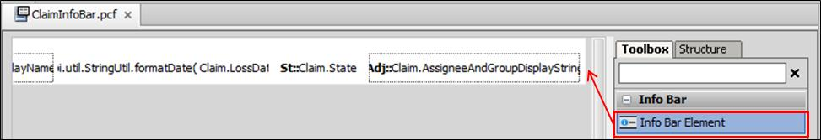

1. Set the properties for the Info Bar. The value should be set to Claim.ClaimNumber.

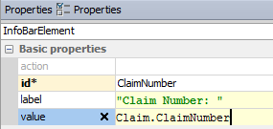

1. Start the server or reload the metadata (from ClaimCenter, enter ALT + SHIFT + L).



Part 1 - Temporary claim numbers

1. In a package named acmelab.cc.plugin.claimnumber, create an implementation of the claim number plugin that meets the following conditions. (This part of the lab is compatible with the base application's claim number field validator.)

**Temporary Claim Numbers**

* The format should be 777-77-NNNNNN, where:
  + 7 is the digit 7.
  + NNNNNN is a six-digit number.

**Permanent Claim Numbers**

* Use the same logic as the temporary claim number logic.

1. Test your plugin by creating a new auto claim. The following outlines the minimal data needed at each step.
2. Search for Personal Auto policies and select any policy. Note the insured's name.

Loss Date: Select any loss date in the past.

(Once you reach Step Two, you should be able to see the temporary claim number.)



1. STEP TWO: Reported By | Name: (the insured)

(Ignore any Duplicate Claim warning at the end of Step Two.)

1. STEP THREE: Loss Cause: Animal

Location: (the one pre-populated location)

1. From Step Three, you can click the Finish button.

You should now be able to see the permanent claim number. This should be different from the temporary claim number.



Part 2 - Enhanced implementation of claim numbers

1. Modify the manner in which permanent claim numbers are generated to meet the following conditions. You can leave the temporary claim logic as is. (This part of the lab is not compatible with the base application's claim number field validator.) Remember to restart the server after modifying fieldvalidators.xml.

**Permanent Claim Numbers**

* The format should be XXX-CL-NNNNNN, where:
  + XXX is a three-character string generated from the claim's Loss Type:
    - AUT for Auto
    - GLB for General Liability
    - PRP for Property
    - TRV for Travel
    - WCP for Workers' Comp
  + CL are the literal characters "CL".
  + NNNNNN is a six-digit number that is 1 or greater. The sequence used for permanent numbers should be unique to permanent numbers. It should not be shared by temporary numbers.

1. Test your plugin by creating a new auto claim. The following outlines the minimal data needed at each step.
2. Search for Personal Auto policies and select any policy. Note the insured's name.

Loss Date: Select any loss date in the past.

1. On Step Two, verify that temporary claim numbers are still generated as expected

Reported By | Name: (the insured)

(Ignore any Duplicate Claim warning at the end of Step Two.)



1. Loss Cause: Animal

Location: (the one pre-populated location)

1. From Step Three, you can click the Finish button.

You should now be able to see the permanent claim number.

